Using Fireworks

- Open Fireworks
- create a document 200 pixels (7cm) x 200 pixels with a transparent background.
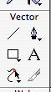

- Select the text tool, font and type your name in a font that fits the document.

- Centre this

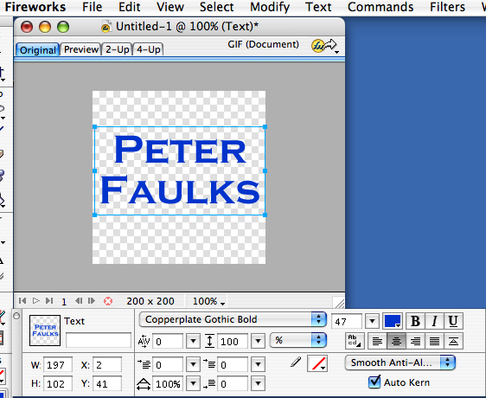
Font style
Font sizing slider
Centre

- Select the text box with the black arrow
- create an effect using the + button on the effects

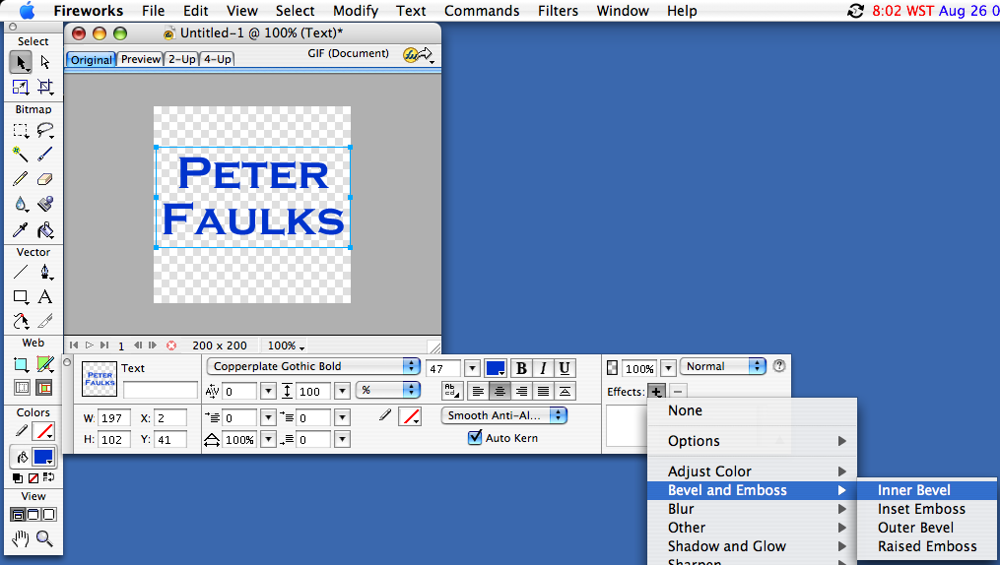

I choose Inner Bevel you can adjust the settings to suit
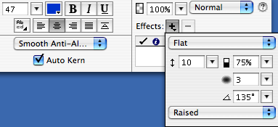

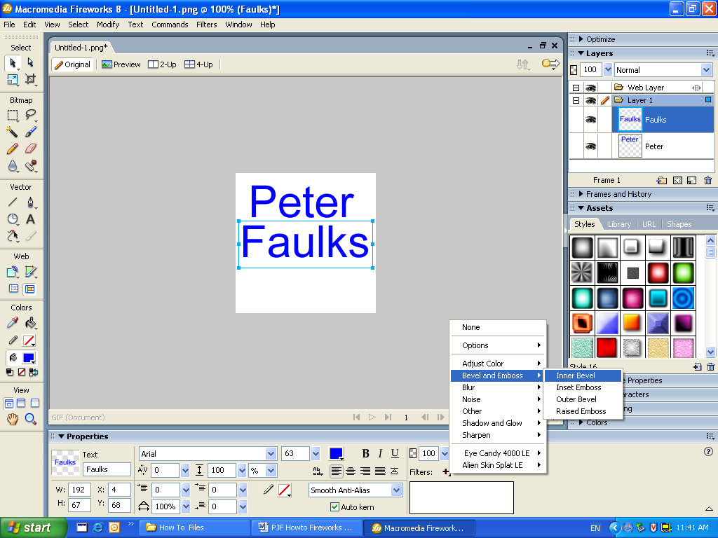
Windows environment Filters + and Bevel and Emboss

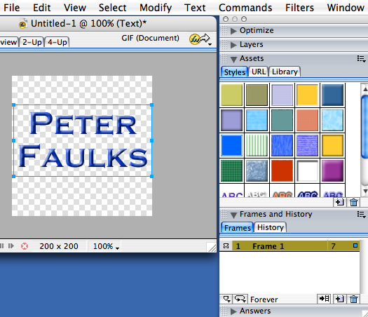
In the frames window you can see we have frame 1
Playing at 7 fps

With Frames

Add a duplicate frame
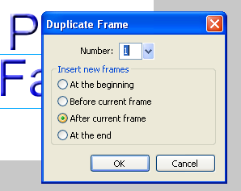
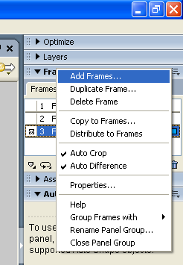

and place it after the current frame.

Save at least three duplicate frames
On the second duplicate frame remove the Filter effect click on the -
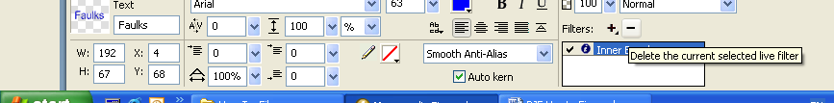
For each name remove one example of the effect

Hit play to see your animation and adjust to make the animation more exciting.

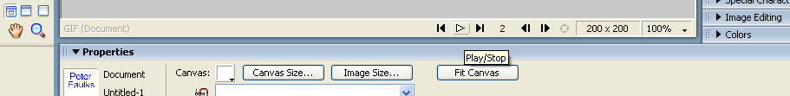

Save as animated Gif


Next few lessons we will add more animation and effects

We will now make some rollover buttons for our task items

- Open Adobe Photoshop
- Make your page size 125 pixels by 25 pixels 72 dpi and transparent 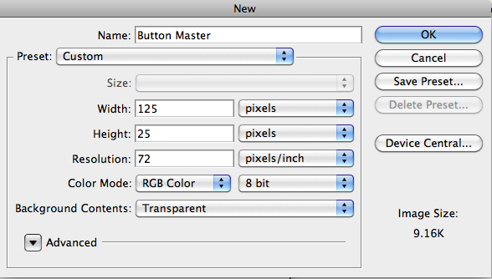
- Title this Button Master
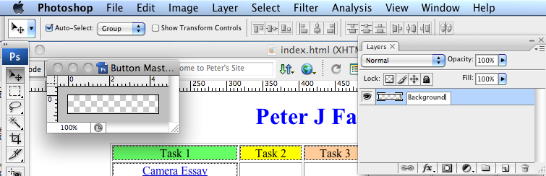
- Name this layer background
- Duplicate the layer (drag it down to the file icon
- Name this layer Home 1
- Select the layer Home 1
- Use Edit - Fill… to select a fill colour
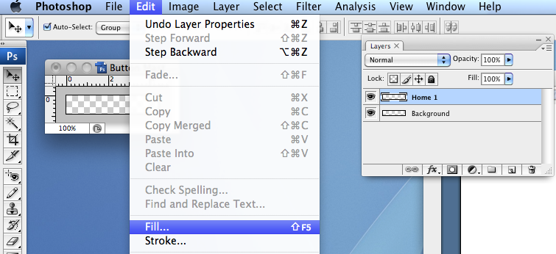
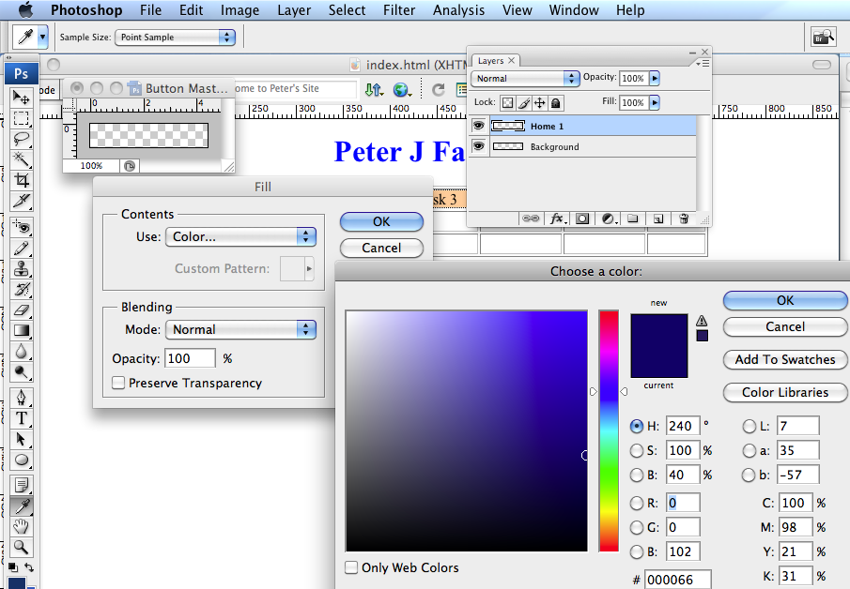
- Select a colour for the background that you like
- The with the layer still selected go to Layers and select Bevel & Emboss
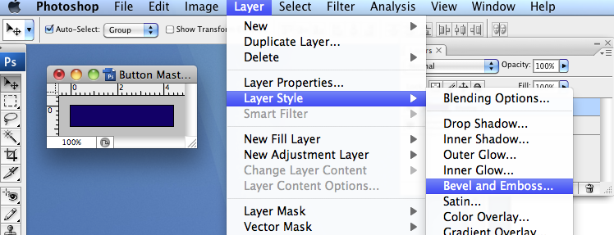

Play a little with the effects to see which you like
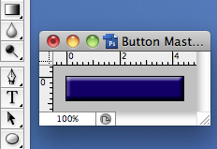
- Click on the font button and type Home
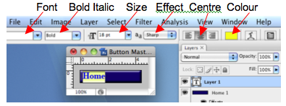

I chose Arial as the font, bold and size 18pt in Yellow

- Ensure that the font size fits onto the button and select a colour that compliments the background
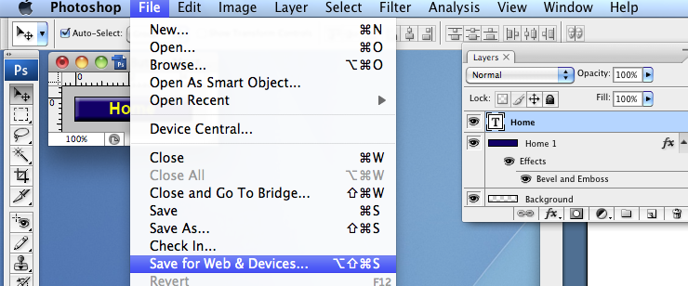

- Save this for Web & Devices… as Button-home1.jpg into your Assets folder
Make your rollover change
- Duplicate the background layer and change the colour and do not use the bevel and emboss (if you want a good effect).
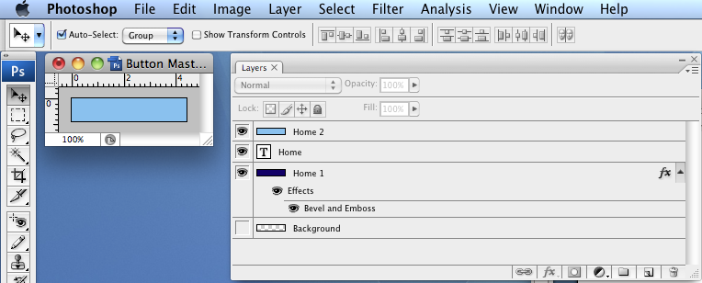
- Duplicate the Home text layer and change the font colour (ONLY)
Note you may need to move the layer up so you can see the words
- Save for Web & Devices as Button-home2.jpg (to your Assets folder)
- Now we will insert this button into Dreamweaver as a rollover and test that it works

Open Dreamweaver and find your page index.html
We will insert a table to hold our buttons

- Go to Dreamweaver and make a table 1 row by five columns leave Border at 1 to show a border (Border 0 = no border - Border 5 = thick border)
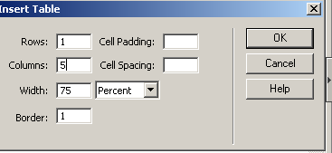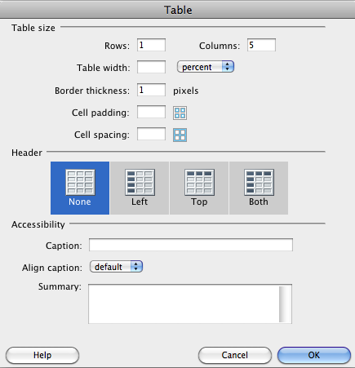

- Click in the first cell and from the menus bar (top of screen) select Insert
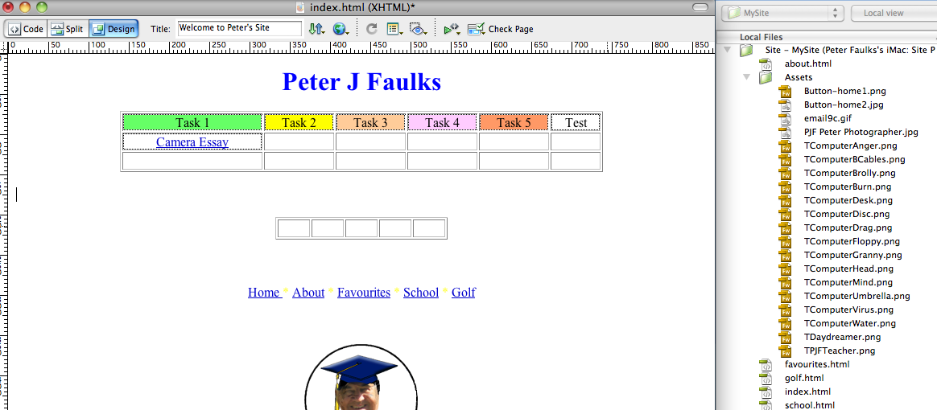
- Click on Insert interactive images – Rollover Image
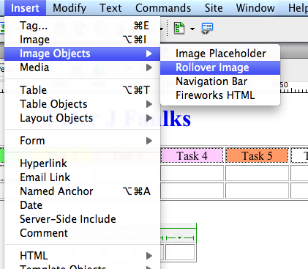

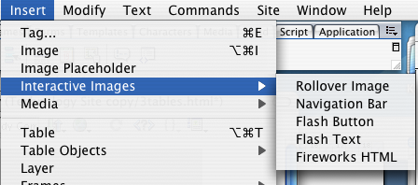
Older version of Dreamweaver

- Title this home
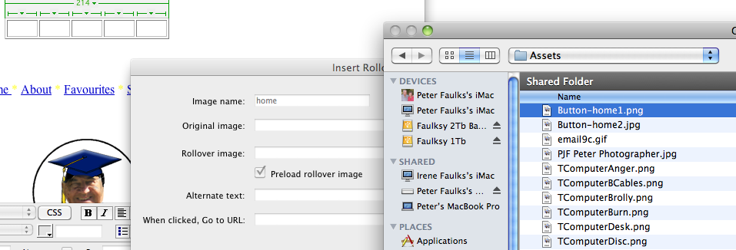

- Find the Original image (Button-home1.png or jpg) in your Assets folder
- Find your Rollover image (Button-home2.jpg) in your Assets folder

- Browse to the first image (Button_home1.jpg)

- Then click Browse… to add (Button_home2.jpg)

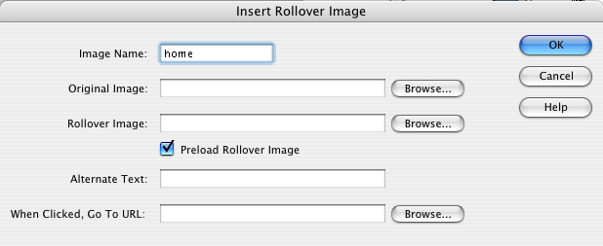
- Browse to index.html in your Mysite folder

- Click O.K. and your first rollover button has been inserted
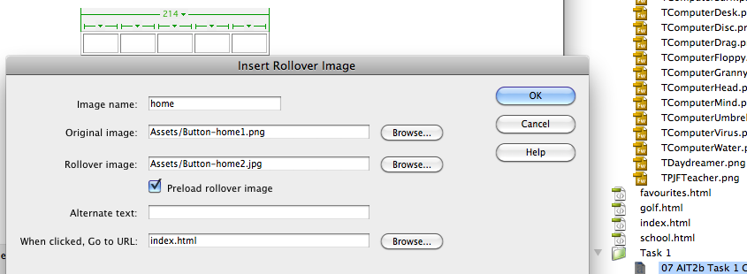

- Test in a browser. Screen view
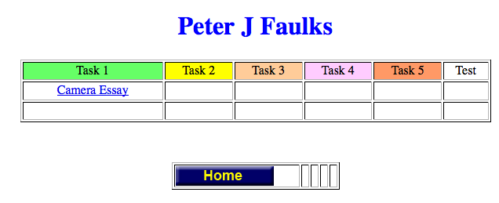

View with mouse over button
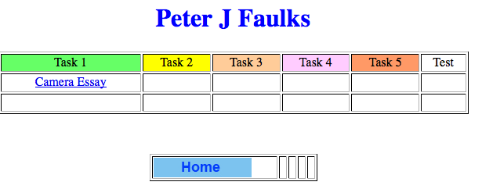
Test that the link works if so go back to Photoshop and make the following buttons (Use your exiting web pages (topic) )

Repeat this process making five sets of buttons (ten different graphics).
Set 1 = HOME button Button_home1.jpg Button_home2.jpg (DONE)
Set 2 = Page1 button Button_About1a.jpg Button_About1b.jpg
Set 3 = Page2 button Button_Favourites1a.jpg Button_Favourites1b.jpg
Set 4 = Page3 button Button_Golf1a.jpg Button_Golf1b.jpg
Set 5 = Contact button Button_Contact1a.jpg Button_Contact1b.jpg

- Save your files to the Assets folder
- Insert images as Rollover buttons
- Test your rollovers (Preview in Browser)

Remember duplicate existing files in Photoshop

Save this file as Buttons Master.psd ( to your working stuff folder - you may want to add more buttons later)

- Duplicate the home text layer drag the locked background to the Create a new layer icon called Home copy (this is the layer where you will type a new text using the Text tool)
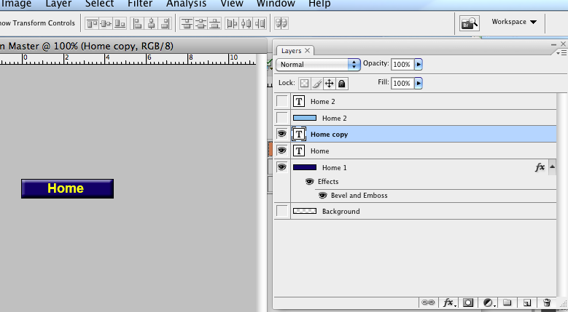
With the new layer selected type Page 1
Duplicate the Home 2 layer and change this to Page 1
Save each as Button_About1a.jpg and then Button_About1b.jpg

Note Always use the 1a and 1b not 1 and 2 I might have pages numbered in sequence and Page 2 might refer to a completely different page.

Your Photoshop file should look like this.

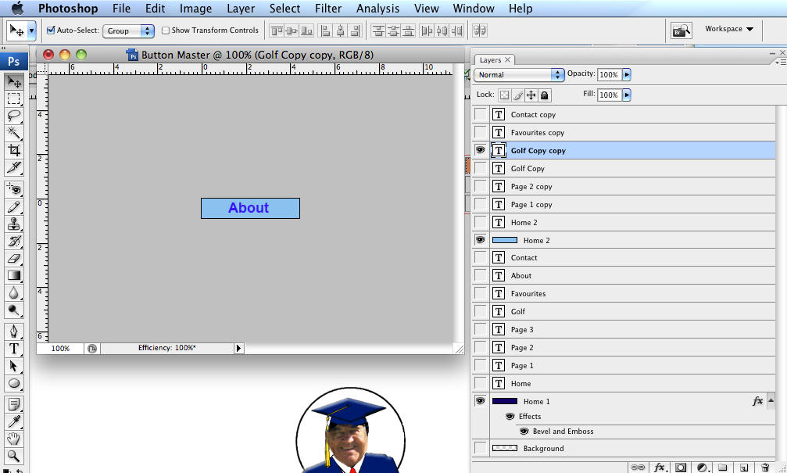
Linking (find your saved image files)
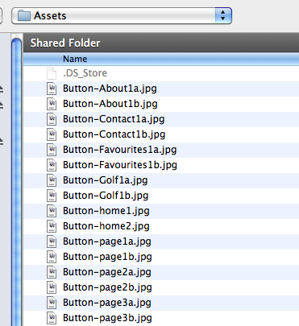

Once you have created your rollover buttons click go back to Dreamweaver and insert the Rollover images into the table with links

Browse or use the point to file for each link.

For the contact button your link will be: (your name)

mailto:
For Contact

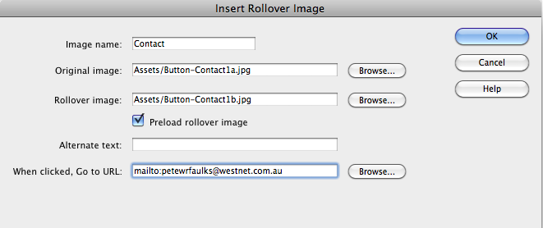

Check that all the links work and save you work.

Select all of the table including the buttons and copy them to each page.

Well Done

